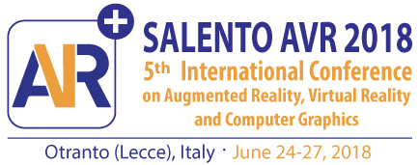

Partnership Contact Form
(please send by email to info@salentoavr.it)

- Please specify what kind of institution you represent:

Company
University or research center
Government institution

- Please fill in the institution information:

Institution name:
Institution Description:
Contact name:
Email:
Phone:
URL:
Other relevant information:

- In what way would you like to be associated with this event:

Link exchange
Demo session
Exhibition desk
Sponsoring a keynote speaker
Sponsoring an award
Sponsoring a social event

